**Aim:** Data Acquisition:

- Perform data acquisition using:

- USB Write Blocker + FTK Imager

**ProDiscover Basic:**

ProDiscover Basic has a built-in reporting tool to present findings as evidence for legal proceedings. You gather time zone data, drive information, Internet activity, and more, piece by piece, or in a full report as needed. The product supports a wide variety of windows and linux file systems. ProDiscover ensures that both the capturing and analysis processes are performed by applying forensically sound methods. The resulting reports meet evidentiary quality requirements.

**Steps:**

**Step 1**: First Open Prodiscover Basic and start with new case.

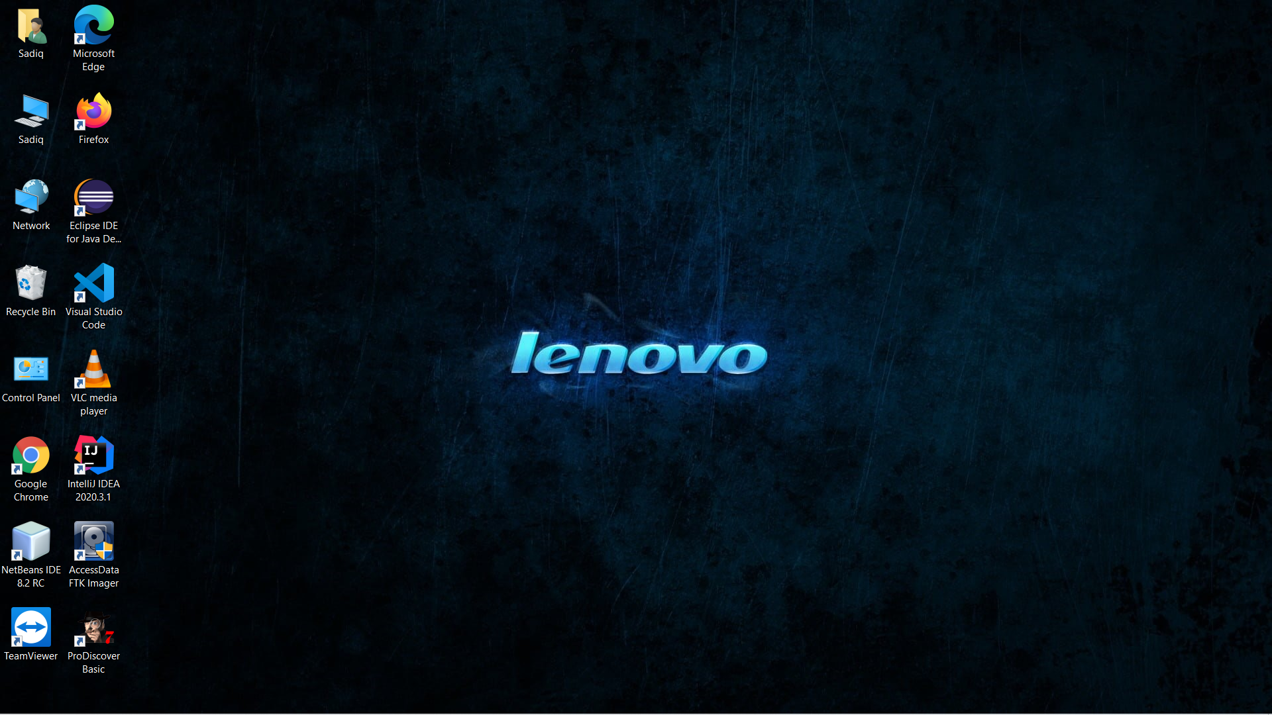

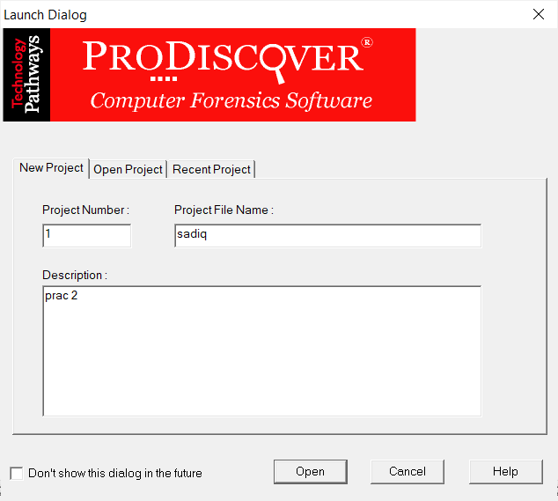

**Step 2:** The created project appears in left pane and select

Add>capture & add image.

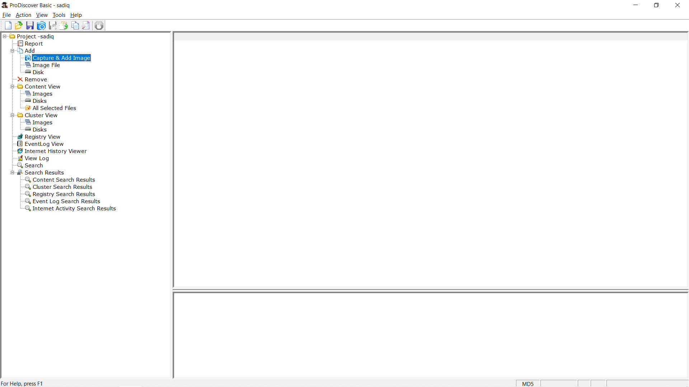

**Step 3**: fill the details as below. And click ok.

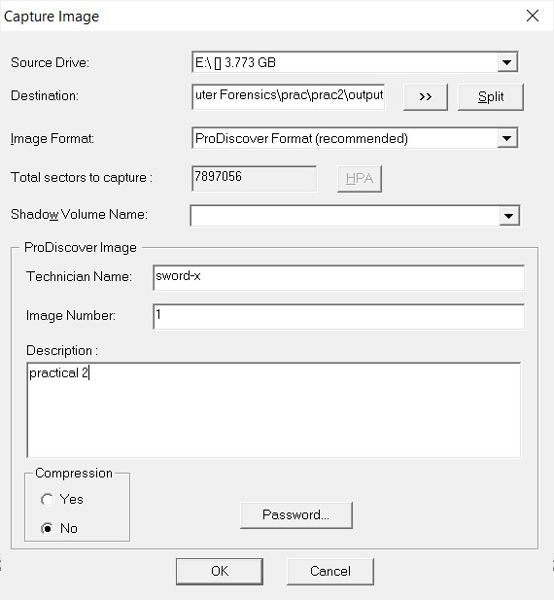

**Step 4**: capturing of image starts.

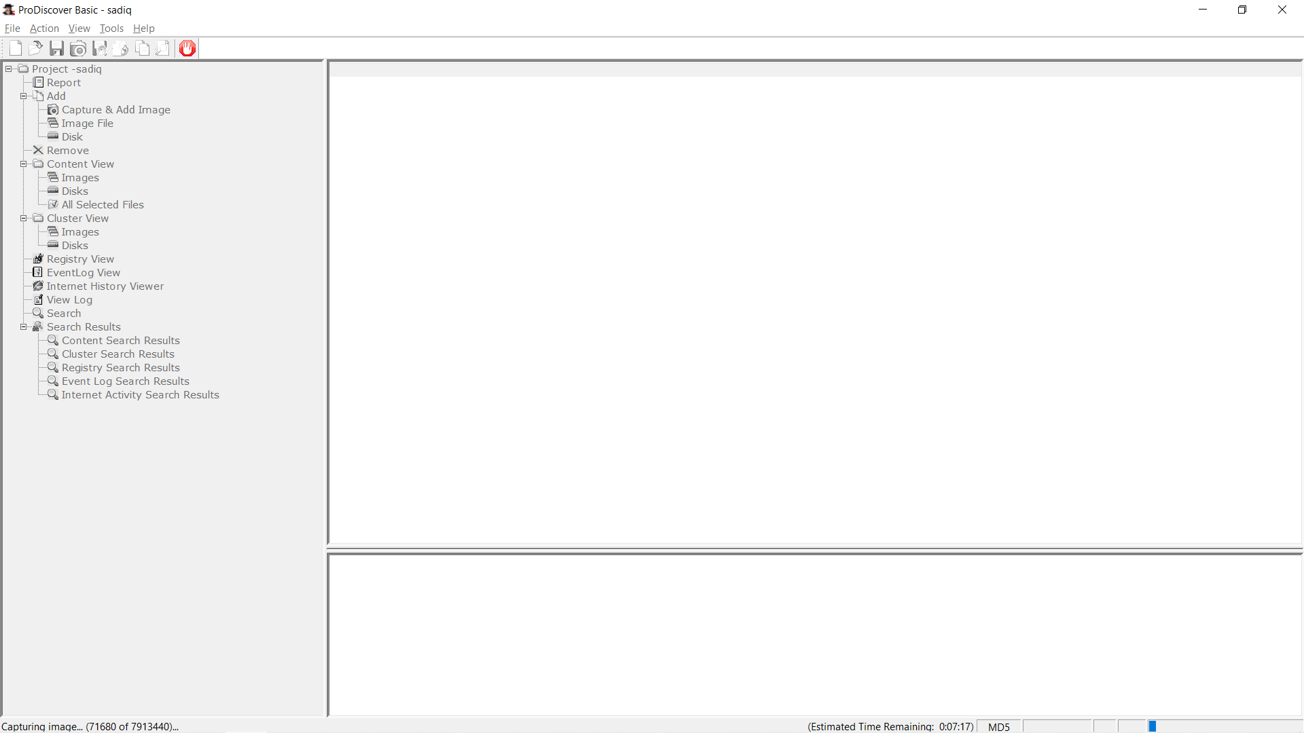

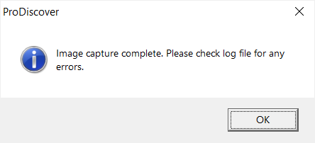

**Step 5**: Open the image created, go to Add > Images in left pane.

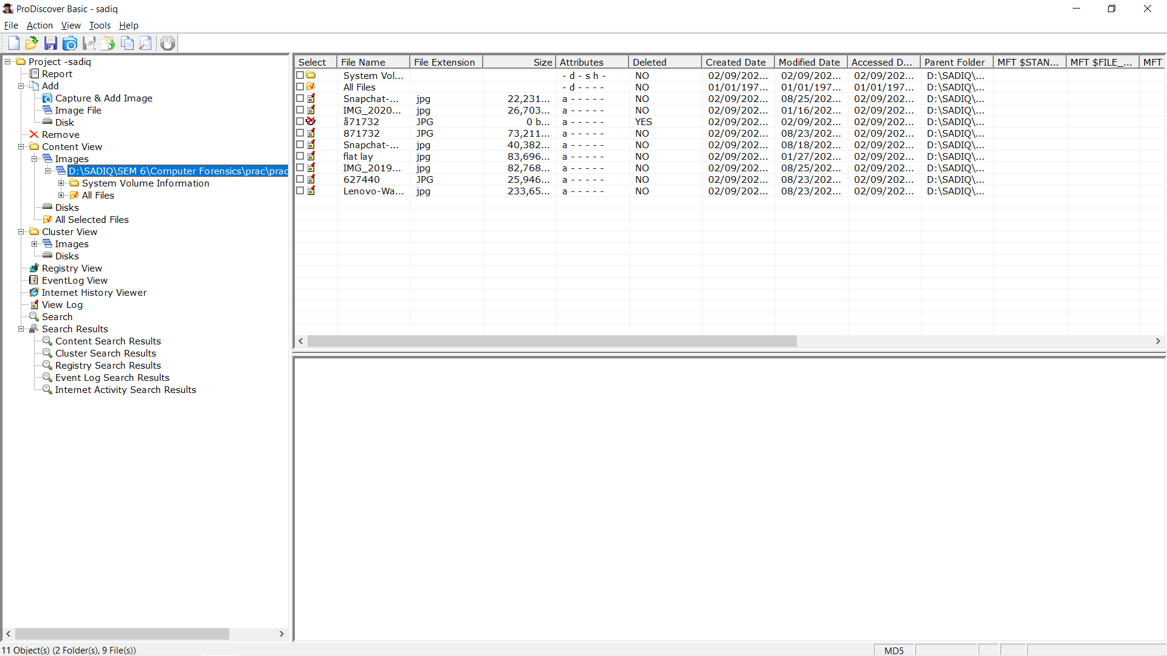

**Step 6**: Click on any File and type a comment.

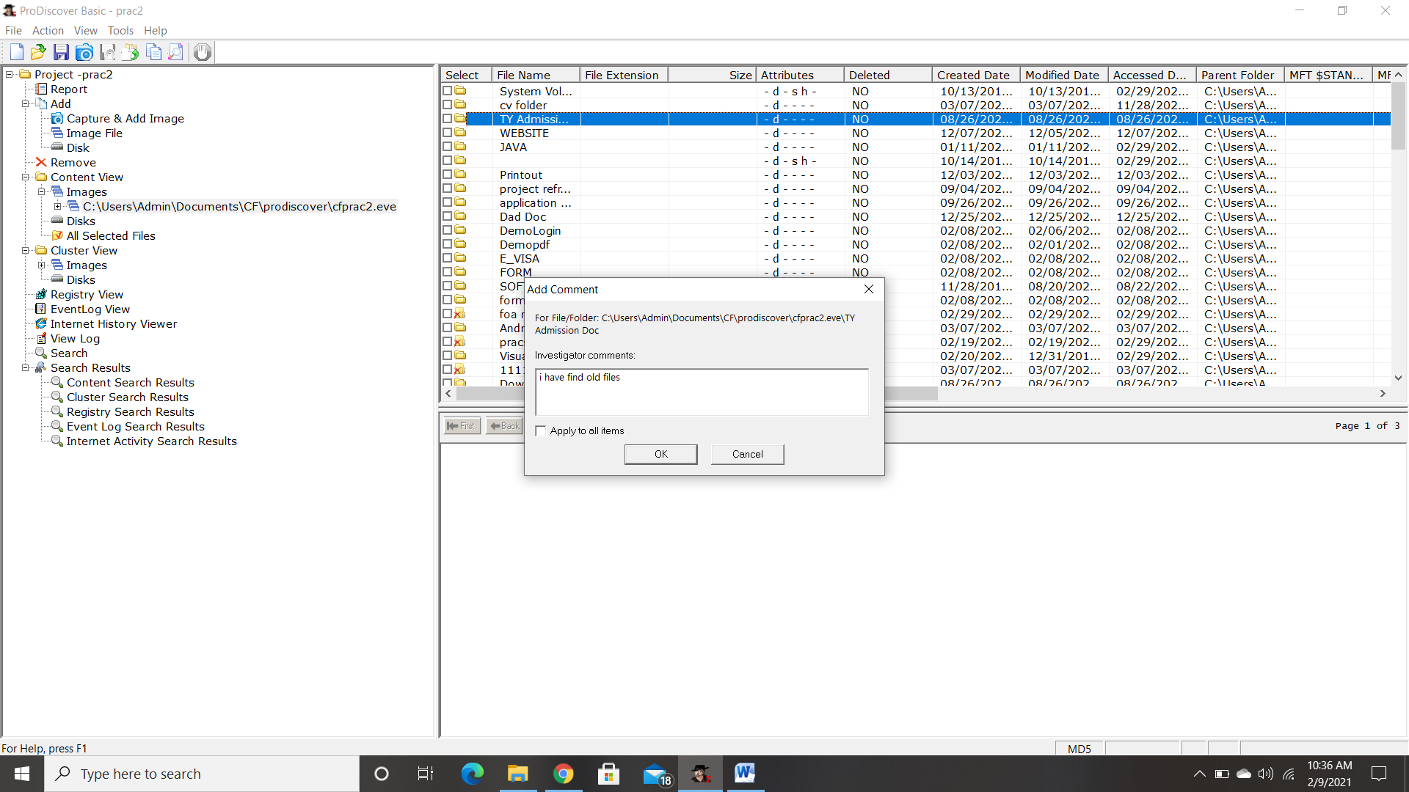

**Step 7** : the cluster view is seen from the cluster view in left panel.

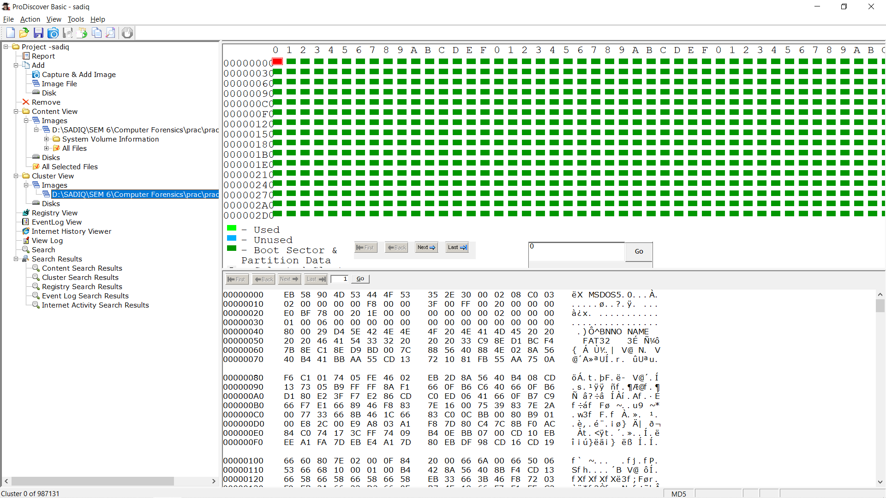

**Step 8** : We can also view gallery view by Right Click.

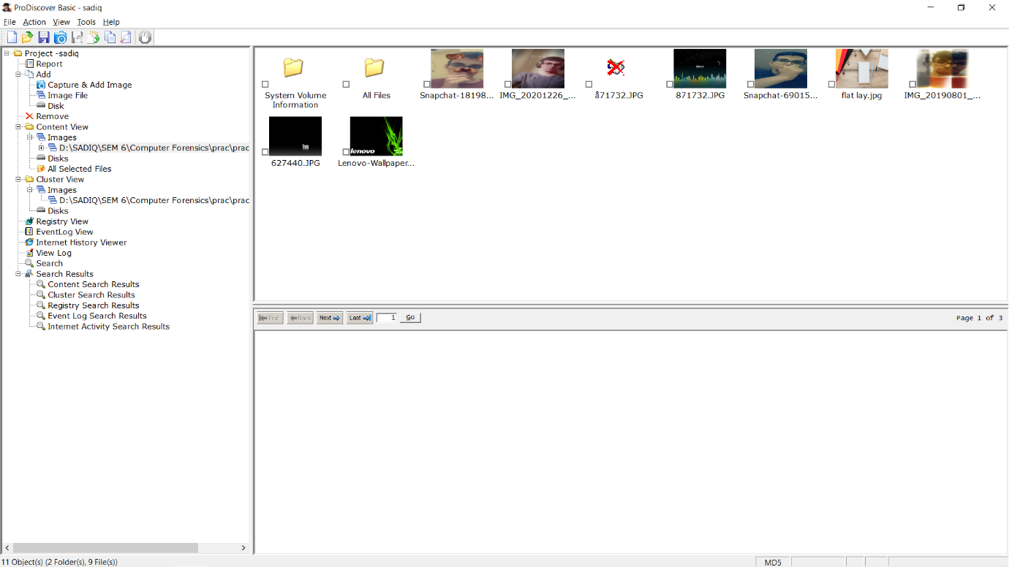

**Step 9:** Keyword search. Click on Search in left pane and Enter the file name to be searched in the image created.

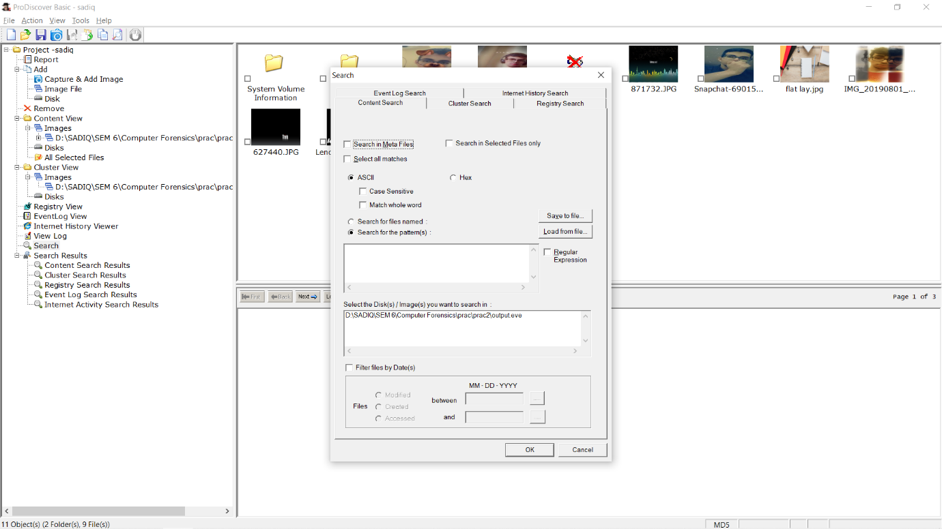

**Step 10** : Output of Keyword search.

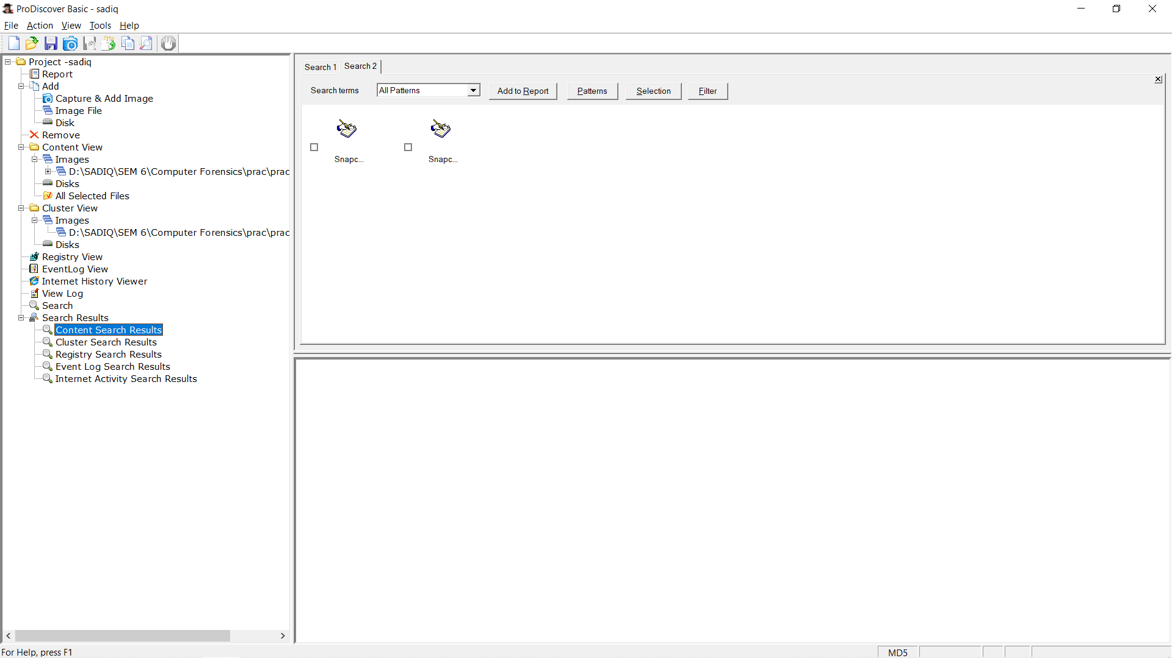

**Step 11** : Click on View>Report.

